Unit Testing Cat Pound Exercise

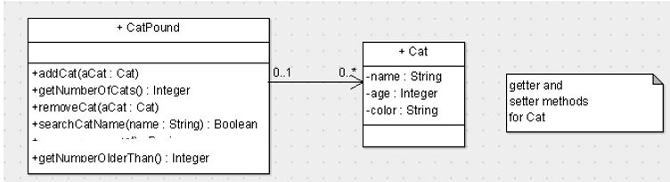

A CatPound contains a collection of cats.

We assume a cat is identified by its name (assume unique).

The CatPound will implement the following User Stories

1. As a cat pound assistant, I want to be able to check how many cats are in the CatPound so that I will know if we have reached our capacity
2. As a cat pound assistant I want to be able to add a cat to the CatPound so that all cats accepted by the pound are accounted for
3. As a cat pound assistant I want to be able to remove a cat from the CatPound so that a cat is removed when it is no longer resident in the CatPound.
4. As a cat pound assistant I want to be able to search by cat name so that I can locate a cat with a particular name.
5. As a cat pound administrator I want to know how many cats over a certain age are present in the pound so that old cats can be put down.

First write a unit test class CatTest for the Cat that tests the constructor and the getters and setters. Normally you would not do this as the tests are trivial.

Now we will test the Cat Pound functionality – **try and write the tests before the code NB**

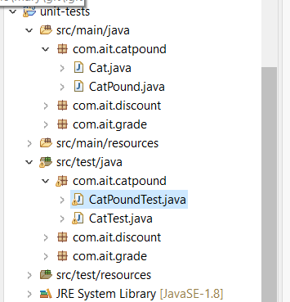

**User Story 1 – check number of cats in pound**

Test 1-1 – Before any cats are added to the pound, there should be no cats in the pound

Note: Other tests for this user story will be completed as part of Story 2 and 3 after cats have been added or removed. Test 2-1 is duplication of this test also but we will leave it here for completeness

**User Story 2 – adding a cat to the pound**

Test 2-1 An empty cat pound (no cats added) should return zero when the number of cats is retrieved from the cat pound.

Test 2-2 – Adding a cat to an empty pound should return one when the number of cats is retrieved from the pound

Test 2-3 – Adding two cats to an empty pound should return two when the number of cats is retrieved from the pound.

**User Story 3 – removing a cat from the pound**

Test 3-1 If a cat is added to the pound and then removed, test that number of cats is reduced Note: the **remove** method removes an object from the arrayList.

**User Story 4 – search for a cat by name**

Test 4-1 Search by name. Check if a cat with a specific name is in the pound. Check that true is returned if the cat has been added to the pound, otherwise false.

**User Story 5 – search for number of cats greater than a certain age**

Test 5-1 Search by age. Check correct value is returned.